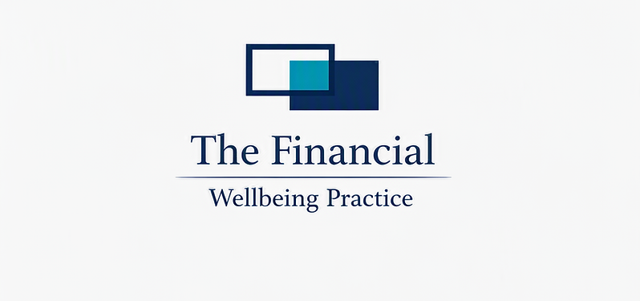

Snowballing Debts

Snowballing Debts
A clear, practical guide to using the Snowball Method to reduce stress, build momentum, and pay off debt faster.

What We Do
The Snowball Method focuses on paying off your smallest debt first, while keeping minimum payments on all others.

Steps
- List all your debts from smallest balance to largest.
- Pay minimums on every debt.
- Put any extra money toward the smallest debt.
- When it's cleared, roll that payment into the next smallest debt.
- Repeat until all debts are gone.

Why We Do It
The Snowball Method works because it creates quick wins.
- Small debts disappear fast.
- You see progress early.
- Motivation increases.
- Stress decreases.
- You feel in control again.
This approach is especially powerful when you're feeling overwhelmed or stuck.

The Outcome
By focusing on one debt at a time, you:
- Build confidence quickly.
- Reduce the number of debts faster.
- Create a predictable repayment rhythm.
- Stay motivated long enough to finish the plan.
Small wins lead to big change.

Snowball Template
Use this table to organise your debts and track your snowball progress.
Debt | Balance ($) | Status

Action Plan
- Choose your smallest debt.
- Add $10-$20 extra each pay cycle.
- Roll payments forward as debts clear.
- Update your tracker weekly.

Notes
Feel free to write your notes here:

