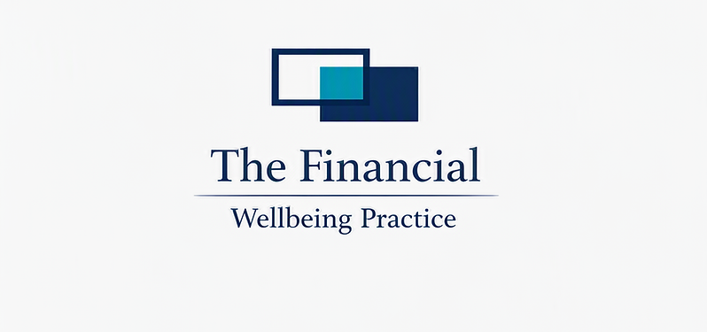

Avalanche Method Debt Repayment Guide

  - A practical client download for reducing interest, building momentum, and paying down debt strategically.

What the Avalanche Method Is
The Avalanche Method is a structured debt-repayment strategy that focuses on clearing the debt with the highest interest rate first. Instead of choosing debts based on balance size or emotion, this method targets the debt that costs the most over time.
By prioritising high-interest debt, clients can reduce the total interest paid, shorten their payoff timeline, and create a clearer path toward financial stability.

Why Interest Rate Matters
Interest is the hidden cost of debt. High-interest balances grow faster, absorb more of each repayment, and can make progress feel slower. Paying down the highest interest debt first helps reduce the fastest-growing cost in the client’s repayment plan.

Interest Cost Example
Debt Type | Balance | Interest Rate | Monthly Interest Cost
Credit Card A | $3,000 | 22% | $55
Credit Card B | $2,500 | 14% | $29
Personal Loan | $8,000 | 10% | $67
Car Loan | $12,000 | 6% | $60
Even though Credit Card A has a smaller balance than the personal loan, its higher interest rate makes it more expensive relative to the balance. The Avalanche Method targets this type of debt first.

How the Method Works
- List all debts from highest interest rate to lowest.
- Continue making minimum payments on every debt.
- Direct any extra repayment money toward the highest-interest debt.
- Once that debt is cleared, roll the freed-up payment into the next highest-interest debt.
- Repeat the process until all debts are paid off.

Avalanche Priority Example
Debt Name | Balance | Interest Rate | Priority
Credit Card A | $3,000 | 22% | 1
Credit Card B | $2,500 | 14% | 2
Personal Loan | $8,000 | 10% | 3
Car Loan | $12,000 | 6% | 4

Why This Method Works
The Avalanche Method works because every extra dollar goes where it saves the most interest. As high-interest balances fall, more of each repayment goes toward reducing principal instead of covering interest charges.

Client Action Plan
- Identify the highest-interest debt.
- Add a realistic extra repayment amount each pay cycle.
- Track balances weekly or fortnightly.
- Roll payments forward as each debt is cleared.
- Celebrate each milestone to maintain motivation.

What Success Looks Like
- Less interest paid over the life of the debt.
- A shorter and more focused repayment timeline.
- Greater clarity around monthly repayments.
- More money available sooner for savings, goals, or future planning.

Client Notes
______________________________________________________________
______________________________________________________________
______________________________________________________________

